**DBMS - MINI PROJECT**

**“Water Refill Station Management System”**

Submitted By:

Name: Adithya M

SRN: PES1UG20CS621

V Semester Section K

**ABSTRACT**

The purpose of this system is to help its clients for an easier and efficient management of stations without sacrificing costs or output.

This project enables the user to record things that are being purchased by the client. The water refilling station management is capable of viewing the item that is already delivered. Setting up a water refilling station whereby the station will cater to the reproduction of water through selling large and small amounts of volume.

**ER Diagram**

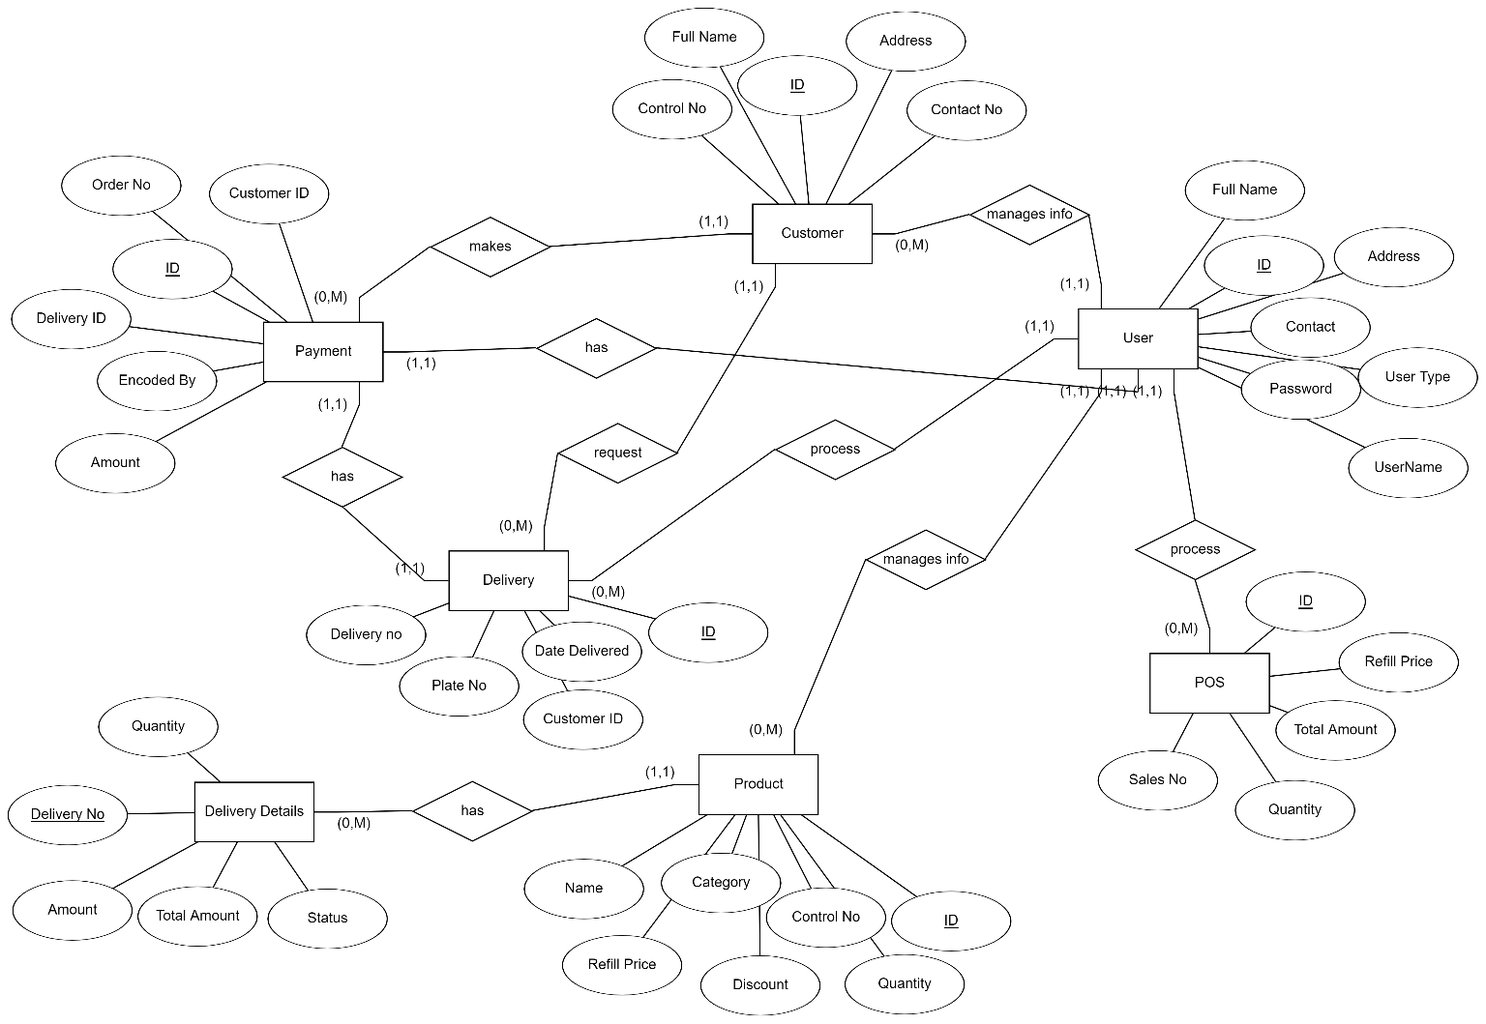

**Relational Schema**

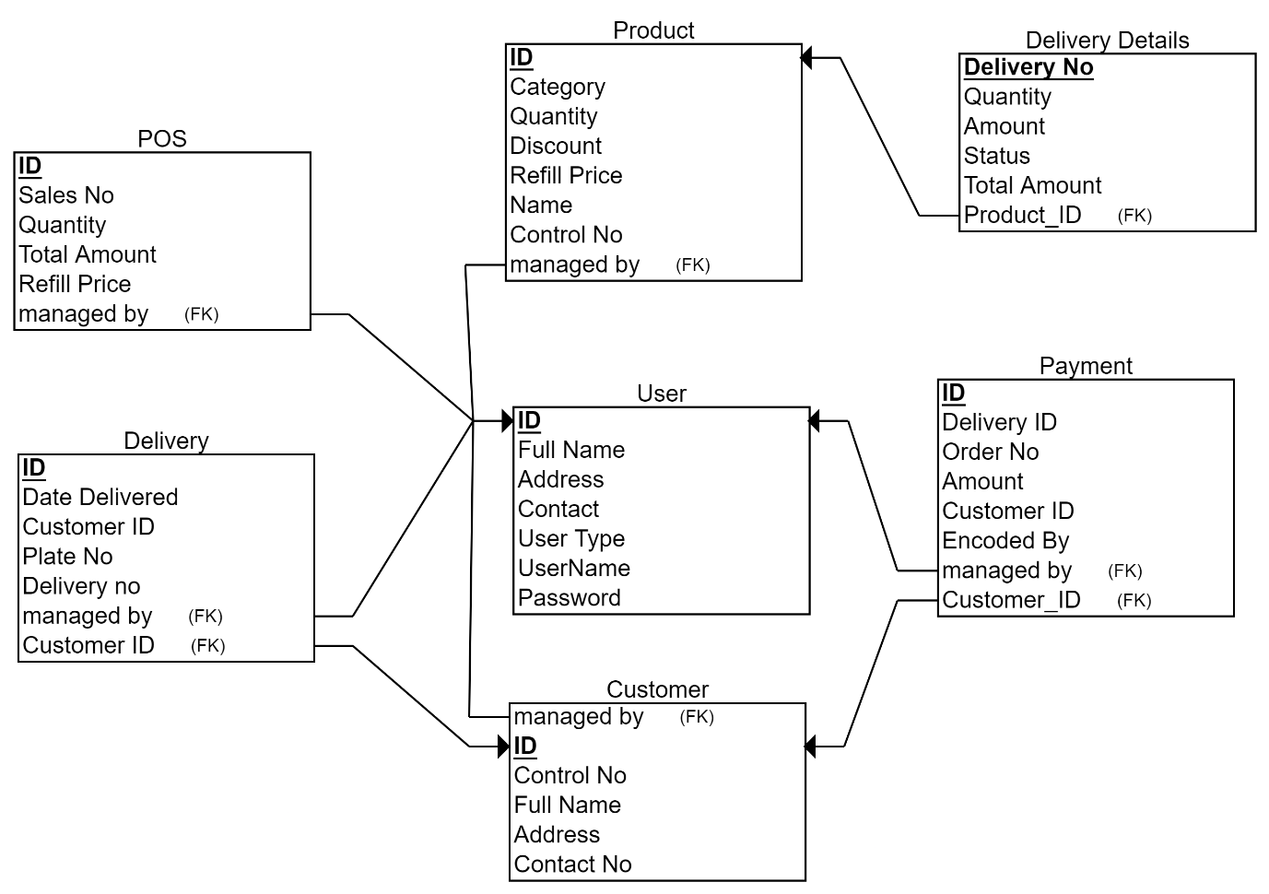

**DDL statements - Building the database**

CREATE TABLE User(

user_id int,

name varchar(20) not null,

address varchar(20),

contact int,

user_type varchar(20) not null,

user_name varchar(20) not null,

password varchar(20) not null,

primary key(user_id)

);

CREATE TABLE Product(

product_id int,

category varchar(20) not null,

quantity int not null,

discount float,

refill_price float,

name varchar(20) not null,

managed_by int not null,

primary key(product_id),

foreign key(managed_by) references User(user_id)

);

CREATE TABLE Customer(

customer_id int,

name varchar(20) not null,

address varchar(20),

contact_no int,

managed_by int not null,

primary key(customer_id),

foreign key(managed_by) references User(user_id)

);

CREATE TABLE POS(

pos_id int,

sales_no int not null,

quantity int not null,

total_price float not null,

refill_price float not null,

managed_by int not null,

primary key(pos_id),

foreign key(managed_by) references User(user_id)

);

CREATE TABLE Delivery_Details(

delivery_no int,

quantity int not null,

total_price float not null,

status varchar(20) not null,

product_id int not null,

primary key(delivery_no),

foreign key(product_id) references Product(product_id)

);

CREATE TABLE Payment(

payment_id int,

delivery_id int not null,

order_no int not null,

total_price float not null,

customer_id int not null,

managed_by int not null,

primary key(payment_id),

foreign key(customer_id) references Customer(customer_id),

foreign key(managed_by) references User(user_id)

);

CREATE TABLE Delivery(

delivery_id int,

delivery_date date not null,

customer_id int not null,

plate_no varchar(20) not null,

delivery_no int not null,

managed_by int not null,

primary key(delivery_id),

foreign key(managed_by) references User(user_id),

foreign key(customer_id) references Customer(customer_id)

);

**Populating the Database**

|  |  |
| --- | --- |
| INSERT into User  VALUES(  1234,  "Adi",  "F Block",  1234567890,  "admin",  "adi",  "pass"  );  INSERT into User  VALUES(  1357,  "Rahul",  "G Block",  123234240,  "moderator",  "rahul",  "pass2"  );  INSERT into User  VALUES(  4321,  "Suhas",  NULL,  924367840,  "intern",  "suhas",  "pass3"  );  INSERT INTO Product  VALUES(  4244,  "Can",  100,  5.0,  10.0,  "Bislerii",  1234  );  INSERT INTO Product  VALUES(  2342,  "Bottle",  75,  1.0,  2.0,  "Aqua",  1357  );  INSERT INTO Customer  VALUES(  53531,  "yehaw",  "Lmao Block",  4834393322,  1234  );  INSERT INTO Customer  VALUES(  53532,  "yehaw2",  "lol Block",  483334422,  1357  );  INSERT INTO Customer  VALUES(  53533,  "yes3",  NULL,  4353322,  4321  );  INSERT INTO POS  VALUES(  3242,  1,  2,  100.0,  10.0,  1234  );  INSERT INTO POS  VALUES(  3243,  2,  3,  200.0,  20.0,  1357  ); | INSERT INTO POS  VALUES(  3244,  3,  4,  300.0,  30.0,  4321  );  INSERT INTO Delivery_Details  VALUES(  1,  2,  100.0,  "pending",  4244  );  INSERT INTO Delivery_Details  VALUES(  2,  3,  200.0,  "on the way",  2342  );  INSERT INTO Delivery_Details  VALUES(  3,  4,  300.0,  "delivered",  3422  );  INSERT INTO Payment  VALUES(  243242,  1,  1,  100.0,  53531,  1234  );  INSERT INTO Payment  VALUES(  243243,  2,  2,  200.0,  53532,  1357  );  INSERT INTO Payment  VALUES(  243244,  3,  3,  300.0,  53533,  4321  );  INSERT INTO Delivery  VALUES(  124213,  DATE("2022-11-20"),  53531,  "KA50HP1234",  4248234,  1234  );  INSERT INTO Delivery  VALUES(  124214,  DATE("2022-01-03"),  53532,  "KA50BC2434",  4248234,  1357  );  INSERT INTO Delivery  VALUES(  124215,  DATE("2022-04-11"),  53533,  "TS50AD2524",  4248241,  4321  ); |

**Tool Used**

* Streamlit
* MySQL
* Python

**Queries**

**Join queries (at least 6)**

**--find product names whose delivery status is pending with join**

SELECT name,

status

FROM product

INNER JOIN delivery_details ON product.product_id = delivery_details.product_id

WHERE status = 'pending';

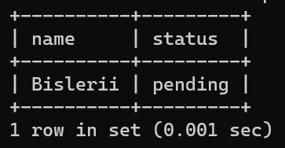

**-- using right join find payment details of customers who have not made any payment**

SELECT c.customer_id, c.name, c.address, c.contact_no, c.managed_by

FROM customer as c

LEFT JOIN payment as p ON c.customer_id = p.customer_id

WHERE p.customer_id IS NULL;

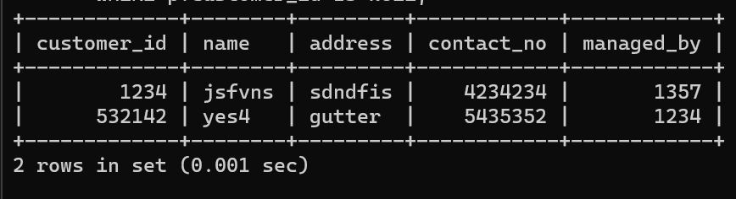

**-- using correlated subquery find the delivery details of the product with the highest refill_price**

select *

from delivery_details

where product_id = (

select product_id

from product

where refill_price = (

select max(refill_price)

from product

)

);

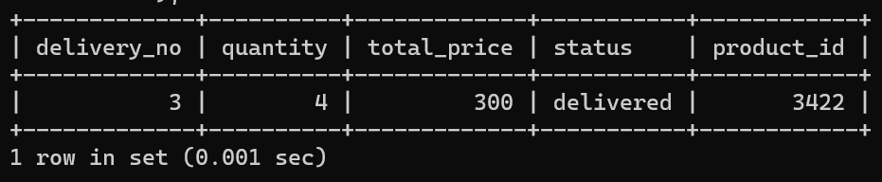

**-- using correlated subquery find the username and password of the user who has highest number of pos**

select user_name,

password

from user

where user_id = (

select user_id

from pos

where pos_id = (

select max(pos_id)

from pos

)

);

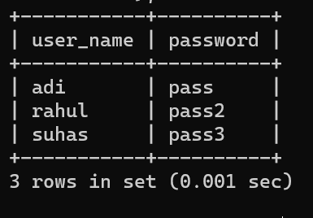

**Aggregate Functions (at least 2)**

**-- count the number of pending deliveries**

select count(delivery_no) as count, product_id

from delivery_details

where status = 'pending';

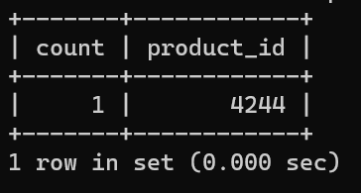

**--average refill price of products whose quantity is less than 10 and category is either bottle or tank**

select avg(refill_price) as average

from product

where quantity < 1000 and category in ('bottle', 'tank');

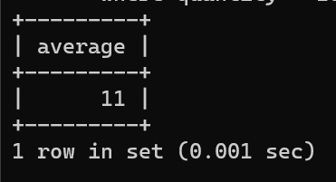

**Set Operations (at least 2)**

**-- using union find the names of the products whose quantity is less than 10 or category is either bottle or tank**

select name

from product

where quantity < 1000

union

select name

from product

where category in ('bottle', 'tank', 'dirty water');

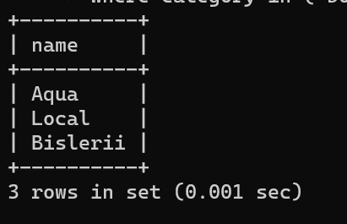

**--using set difference find the payment details of customers who have not made any payment**

select c.customer_id,

c.name,

c.address,

c.contact_no

from customer as c

except

select c.customer_id,

c.name,

c.address,

c.contact_no

from customer as c

inner join payment as p on c.customer_id = p.customer_id;

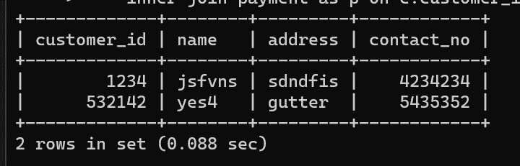

**View (atleast 1)**

CREATE VIEW heavy_ticket_items AS

SELECT product_id,

name,

refill_price

FROM product

WHERE refill_price > (

select avg(refill_price)

from product

);

SELECT * from heavy_ticket_items;

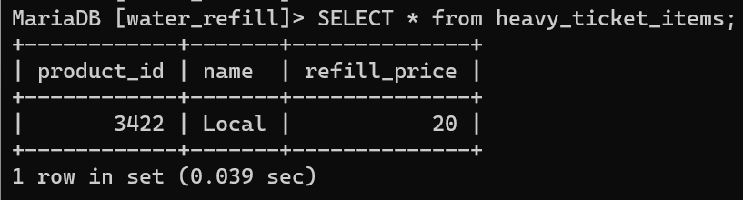

**Triggers (Functions or Procedures)**

**--decrement quantity after delivery status is changed to delivered**

DELIMITER $$

CREATE or replace procedure decrement_quantity(IN p integer, IN q integer) BEGIN

UPDATE product

SET quantity = quantity - q

WHERE product_id = p;

END;$$

DELIMITER ;

DROP TRIGGER update_quantity;

DELIMITER $$

CREATE TRIGGER IF NOT EXISTS update_quantity BEFORE

UPDATE ON delivery_details

FOR EACH ROW BEGIN IF NEW.status = 'delivered'

THEN

CALL decrement_quantity(NEW.product_id, NEW.quantity);

END IF;

END $$

DELIMITER ;

**Before update**

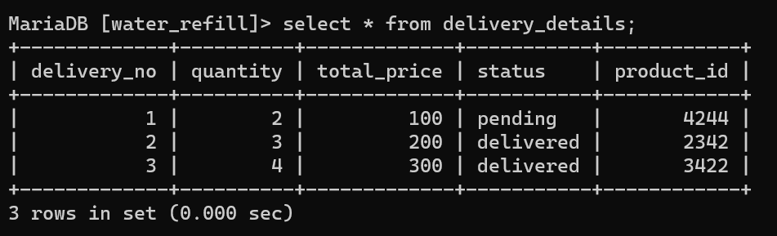

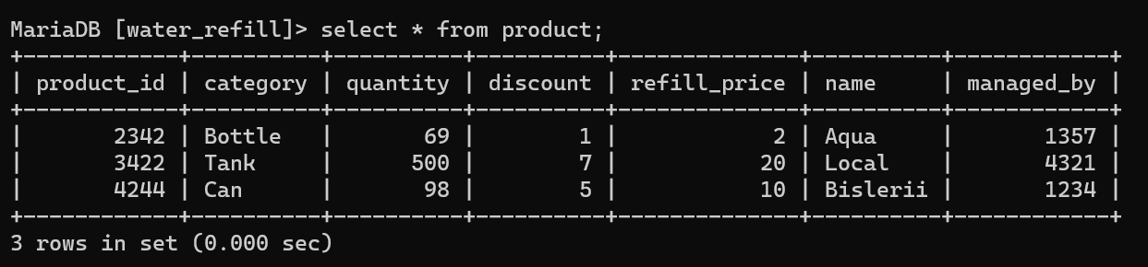

**After update**



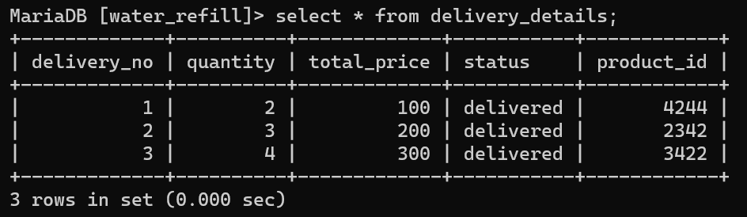

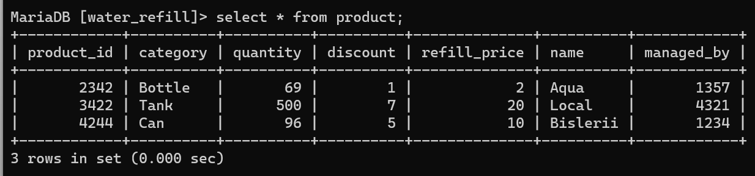

**Developing a Frontend**

